Debugging GC, looking at pixel 150 in one line version. Pixel 150 in left image = 75. The plot below is the MI for the left pixel = 75 for all labels (e.g. all disparities). Should get the best match with the right pixel equal to an intensity of 69.

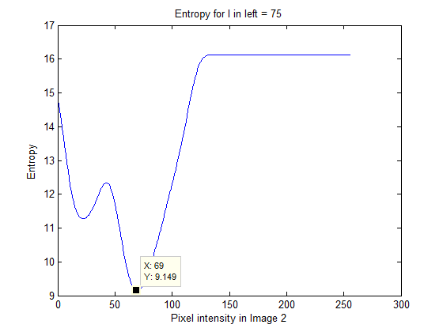

Pixel values across line 214 of right image starting from pixel 214 and going to 214+64

